**UshaKiran Residency Website Content & Flow**

1. Creatives Banners (2-3 no.s or 1 animated video)
2. Overview

UshaKiran Residency offers a perfect blend of modern living and everyday convenience in the heart of Badlapur East.

Just 2 km from the railway station, our 12-storied twin towers—spread across a 10-acre township—feature OC Received, Ready to Move-in 2 BHK homes with top-tier amenities and double lift access.

With 85% of families already moved in, the project also includes a 21,000 sq. ft. commercial complex, ensuring daily needs are close at hand. Designed for comfort, connectivity and quality family time, UshaKiran Residency is your gateway to elevated living.

1. 

LIMTED PERIOD OFFER! FREE FULLY AIR CONDITIONED HOMES WITH MODULAR KITCHEN ON ERVERY BOOKING*

1. Project Highlights

* OC Received & Ready to Move-in 2 BHK Homes

Step into a vibrant community with 85% families already living in. Enjoy the peace of a ready-to-move-in home—no waiting, no uncertainty, just comfort and convenience from day one.

* Convenient Location

UshaKiran Residency is just 10 minutes from Badlapur Railway Station, offering excellent connectivity. The location is close to schools, colleges, supermarkets, and popular getaways like Karjat, Khopoli, Lonavala, Matheran and Kondeshwar, making everyday living and weekend escapes equally convenient.

* Quality Homes

Each apartment at UshaKiran Residency is a cozy retreat, thoughtfully designed to offer comfort and peace amidst the hustle of everyday life. The homes offer a king size carpet area. With dual-side openings that invite natural light and ventilation, every corner is crafted to complement your lifestyle. The project stands out for its meticulous planning, superior design and quality construction.

* Multiple Towers

UshaKiran Residency features an exclusive collection of 20 towers, comprising elegantly designed Ground + 12 and Ground + 7 storied buildings—offering a perfect blend of style, space and urban living.

* Lush Landscape

Nestled in a serene valley surrounded by open skies and lush greenery, UshaKiran Residency offers a tranquil escape. Located on the main Badlapur–Matheran Road at Kharvai Naka, it’s an ideal setting for those who wish to live closer to nature without compromising on connectivity.

1. Amenities

**Your Ideal Lifestyle Awaits**  
Dive into a variety of thoughtfully designed amenities that cater to your every need.

Club House, Well Equipped Gymnasium, Indoor Games, Swimming Pool, Steam Bath, Landscape Garden, Ample Car Parking, Jogging Track, Battery Backup for lifts & Common Area Lights, Decorative Entrance Lobby

1. Configuration & Unit Plan – 2 BHK with Price Rs. 48 Lacs (All incl.)*
2. Gallery
3. Location & Connectivity

10 mins from Badlapur Rly. Station

Temple within the complex

Schools and colleges within nearby area

Hospitals, Playgrounds & Supermarkets are in vicinity.

(Google Map Integration)

1. A Project by Stalwart Implex Pvt. Ltd (Details & Logo) | Site Visit Form Section

UshaKiran Residency is developed by Stalwart Implex Pvt. Ltd., a trusted name with a diverse portfolio. Known for its excellence in real estate development, Stalwart also operates as a leading supplier and exporter of bentonite, showcasing a strong presence across multiple industries.

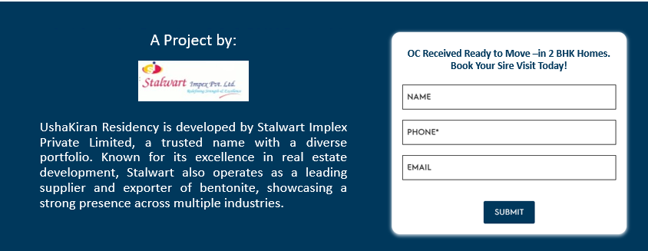

1. Pop Up Form (Automatic after first 7 seconds) and with functionality to close it.

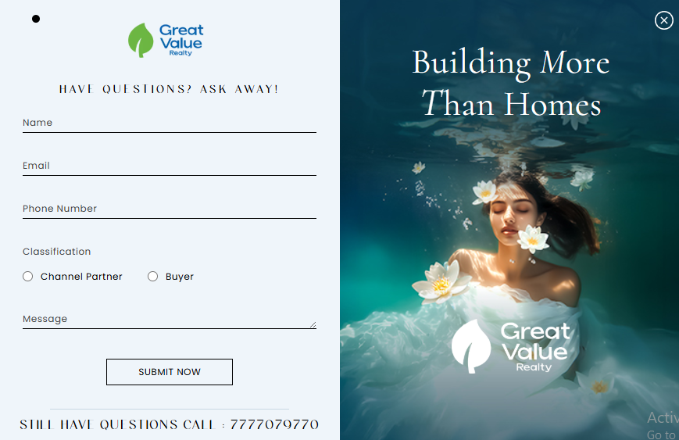

Get in Touch with Us!

Name* Contact No* Email Submit

In landing page theme colours

1. Disclaimer | T&C | Privacy Policy pages (Can be taken from Ushakiran Enclave website – just replace name to Ushakiran Residency)

Call 8888 28 3456 to get in touch with our sales team *(Place this just above the disclaimer and make the no. clickable and open phone dialer).*

Disclaimer: The content & images are for representative purpose only. The plans, images, design, specification, dimensions and other details herein are purely indicative in nature, and these are to be treated as purely informative. | This communication is neither an offer to sell nor a solicitation of any offer to buy any home in the Project. It should not, therefore, be the sole basic of buying / purchase decisions. Any offering is made only pursuant to the relevant Agreement to sale and other related documents, all of which must be read in their entirety before making decision to buy in the Project. | Travel times are as per Google maps under uncongested traffic. It may vary based on traffic conditions. | T&C Apply

All Rights Reserved. Copyright 2025. Ushakiran Residency.

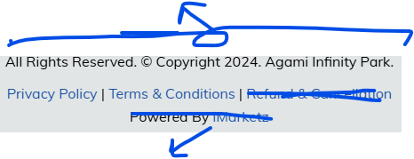

Digital Partner: KonceptKai (clickable link to website <https://konceptkai.com/>)

Other pointers/functionalities:

* WhatsApp chat integration (Chat with us). Whatsapp window to open on clicking
* Make the website into a single page landing page. Only 2 extra pages to be included – Terms & Conditions and Privacy Policy.
* The theme of the website can be same but use different colours (from Fb lead gen ads, white and Ushakiran logo red), animations and text font and styling – to give the feel that the original website has been changes drastically. Some textured background can also be used
* New renders, actual images and stick images will be provided
* Hovering Enquire Now button, Download Brochure when clicked will make the contact form pop up.
* 10 digit mobile no. authenticator to be put in all contact/pop up forms
* Seo and speed optimization to be done
* All submitted date to be linked to a gdrive sheet with timestamp